

CMB Rentals – Design Document

CMB Rentals Inc.

CMPT 291 Group 11

Entity-Relationship Diagram

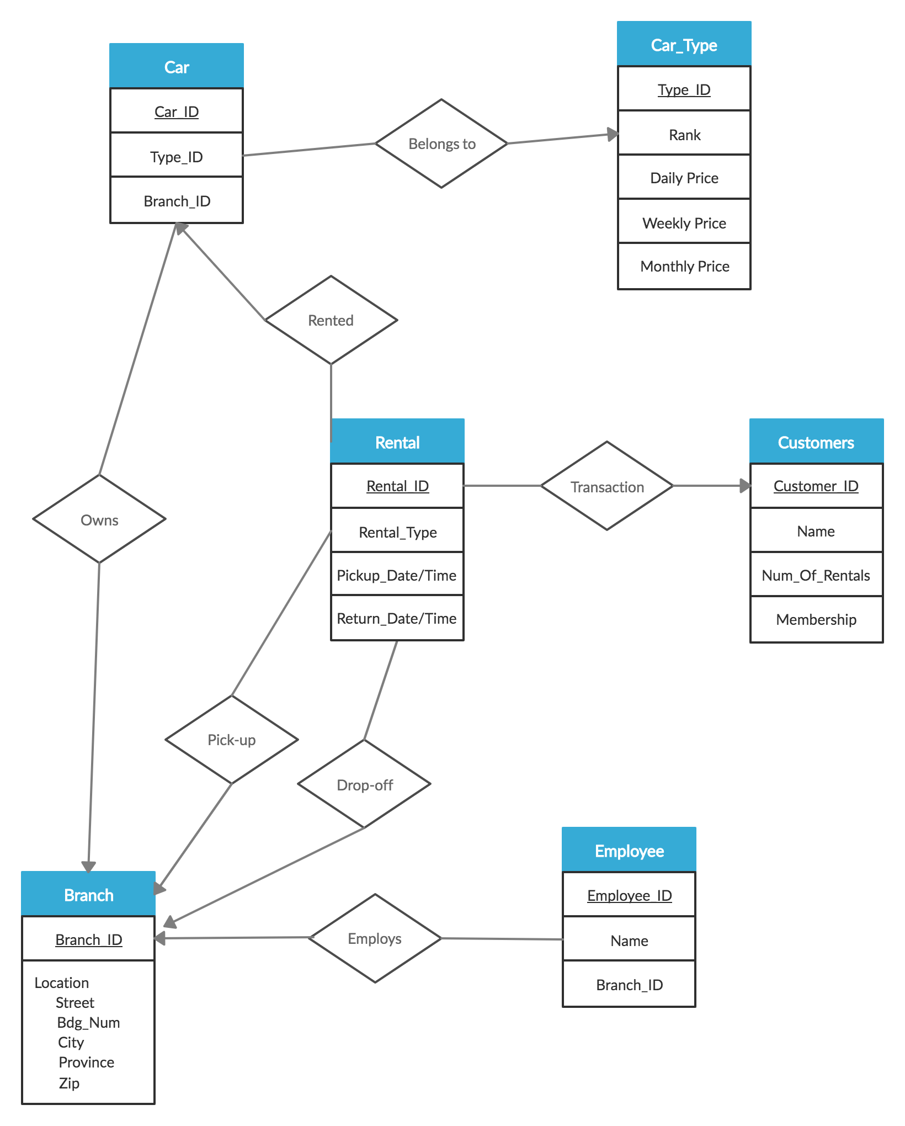

Design Choices

We decided to use Visual Studio for this project, using Windows Forms written in C#. The Windows Forms interface is user-friendly and easy to use, which is perfect for individuals who do not have much experience using computers.